**Alphabet Soup Analysis Report**

1. **Overview** of the analysis: To help the nonprofit charity Alphabet Soup determine which applicants should receive funding from them, a binary classifier needs to be created using neural networks and machine learning to predict if the applicant will be successful if they receive funding.
2. **Results**: Using bulleted lists and images to support your answers, address the following questions:

**Data Preprocessing**

* **What variable(s) are the target(s) for your model:** The target variable is IS_SUCCESSFUL with a binary value of 0 or 1.
* **What variable(s) are the features for your model:** The feature variables are the rest of the variables except EIN and NAME, which were dropped from the dataframe. The CLASSIFICATION variable was used to bin the values where mainly rare variables were used and use as a cutoff.

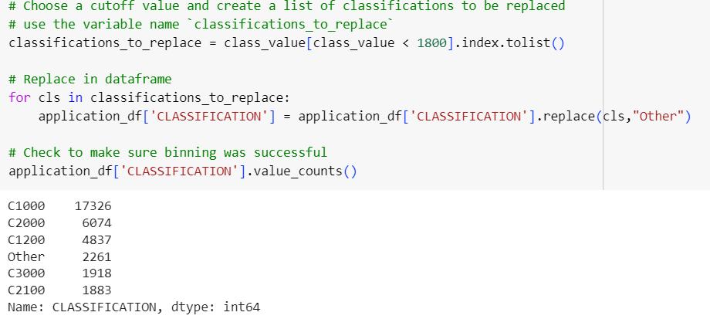

* **What variable(s) should be removed from the input data because they are neither targets nor features:** The variables EIN and NAME were dropped because they are neither target or feature variables.

**Compiling, Training, and Evaluating the Model**

* How many neurons, layers, and activation functions did you select for your neural network model, and why: For the neural network model, the following information was select for the number of neurons with 3 layers and the activation functions ‘relu’ and ‘sigmoid’:

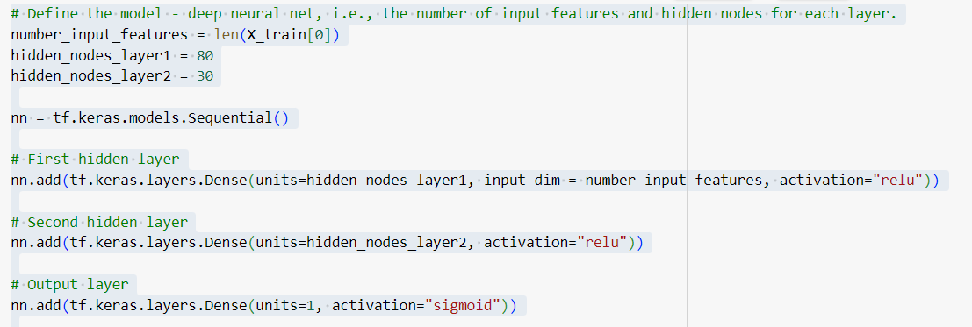

* Were you able to achieve the target model performance: No, I was not able to achieve the target model performance of 75% accuracy. We got an accuracy value of 72%, which is 3% below the desired performance. There were total of 5981 params that were trainable. These might be too many parameters and would need to be updated to achieve the target performance.

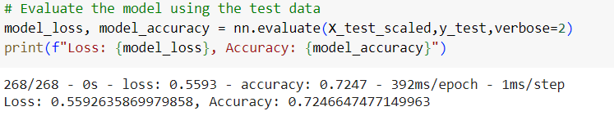

* What steps did you take in your attempts to increase model performance: To increase model performance, we created bins using the NAME field instead of CLASSIFICATION field, which helped improve the performance since the. The number of neurons were also decreased to help improve the performance. The same activation functions were kept, as shown below:

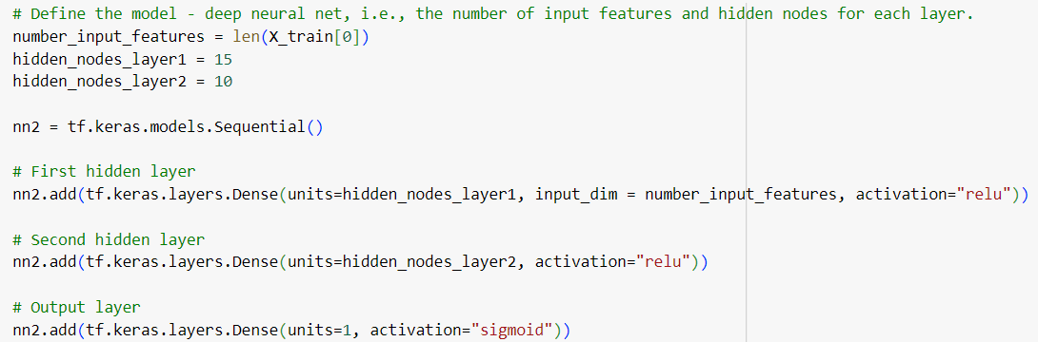

There were total of 2916 params that were trainable and were most efficient in training the model. The target of 75% was achieved with this optimized neural model and by using NAME as bins instead of classification and by decreasing the number of neurons.

